ABSTRACT

Background/Objectives: Brain tumor classification from magnetic resonance imaging (MRI) is a challenging image classification task because different tumor categories may exhibit similar visual characteristics. This study investigates the effect of modifying the EfficientNet architecture for four-class brain tumor classification using the BRISC2025 dataset. The objective is to compare a modified EfficientNet-B3 model with an EfficientNet-B1 baseline under the same experimental conditions.
Methods: The proposed Project Exhibition 1 (PE1) model uses an ImageNet-pretrained EfficientNet-B3 backbone followed by global average pooling, batch normalization, dropout, a fully connected layer with 512 units, GELU activation, and a final four class activation layer. The four classes are glioma, meningioma, no tumor and pituitary tumor. The 5,000-image training portion of BRISC2025 is divided into 4,000 training images and 1,000 validation images, while the official 1,000-image test set is kept completely separate. Both PE1 model and EfficientNet-B1 baseline are trained and evaluated using the same experimental protocol.
Results: The EfficientNet-B3-based PE1 model achieved an accuracy of 98.70% and a macro F1-score of 99.31%. The PE1 model contained 11,488,300 parameters, compared with 6,518,308 parameters for the baseline. Although the PE1 model used a larger architecture, it did not improve classification performance under the evaluated conditions.
Conclusion: The controlled comparison shows that increasing the EfficientNet backbone from B1 to B3 and modifying the classification head did not provide an improvement over the EfficientNet-B1 baseline for the evaluated BRISC2025 classification task. The experiment demonstrates the importance of controlled architectural evaluation when assessing the changes to deep learning models for brain tumor MRI classification.

Keywords: brain tumor; magnetic resonance imaging; deep learning; EfficientNet-B3 ; image classification; BRISC2025

- INTRODUCTION

Brain tumor classification using magnetic resonance imaging (MRI) is an image classification task that involves distinguishing between different tumor categories based on their visual characteristics. Differences in image appearance can make the classification process challenging. Deep learning models, particularly convolutional neural networks (CNNs), can learn from visual features directly from image data and have therefore been explored for brain tumor classification. The reference study also demonstrates the use of deep learning approaches for brain tumor classification using the BRISC2025 dataset.

The performance of a deep learning classification model is influenced by its architecture and model capacity. Different model architectures and configurations may produce different results even when applied to the same classification task. Therefore, evaluating an architectural modification experimentally is important to determine whether increasing model capacity actually provides a benefit.

This study focuses on four categories: glioma, meningioma, no tumor, and pituitary tumor. EfficientNet-B1 as the baseline architecture, while the proposed Project Exhibition 1 (PE1) model uses an EfficientNet-B3 backbone with a modified classification head. The proposed model incorporates a modified classification head in addition to the larger backbone. The main objective is to investigate whether this architectural modification can improve classification performance compared with the selected baseline.

The study is designed as a controlled comparison so that the effect of the architectural change can be examined directly. Both models address the same four-class classification problem and are evaluated using the same experimental protocol. This allows the observed differences in performance to be analyzed in relation to the model architecture rather than changes in classification task.

The main contribution of this work are as follows:
1. Modified EfficientNet-based architecture: An EfficientNet-B3-based model with a modified classification head is developed for four-class brain tumor MRI classification.
2. Controlled comparison: The proposed PE1 model is compared with an EfficientNet-B1 baseline under the same experimental conditions.
3. Performance evaluation: The two architectures are evaluated using standard classification metrics to examine their performance across four target classes.
4. Model and computational analysis: The study examines model parameter count, training duration, and inference time along with classification performance assess the effect of architectural modification.

The study therefore provides an experimental comparison of the EfficientNet-B1 baseline and the proposed EfficientNet-B3 based PE1 architecture for the specific brain tumor classification task.

- BACKGROUND

Brain Tumor Diagnosis and MRI Challenges
We see that gliomas, meningiomas and pituitary tumors make up most of the primary brain tumors seen in imaging. They differ a lot in where they start, how they grow and how they are treated. Gliomas start from cells and often spread into nearby tissue. Meningiomas start from the meninges. Are usually well defined. Pituitary tumors happen in the region at the bottom of the brain. To plan treatment it is essential to tell these types. MRI is the tool for this because it gives great contrast of soft tissue and does not use radiation. Still reading an MRI scan takes a lot of time and relies on the skill of the radiologist and can vary between observers. How a tumor looks also changes with the scanning protocol and the angle of the image. Tumors from types can look similar in intensity and shape, on a single two‑dimensional slice. These challenges push the development of classification systems that can help doctors make decisions.
Deep Learning and Transfer Learning for MRI Classification
Convolutional neural networks are able to learn feature maps directly from images so we do not need to make texture or shape descriptors by hand. Medical data sets however are much smaller than collections of natural pictures because it costs a lot to get expert labels. Training a network from scratch on such small data is easy to overfit. Transfer learning solves this issue by starting the network with weights that were already trained on ImageNet and then changing it for the task. This can be done by training the new classification layers or by fine‑tuning part or all of the backbone. Even though there is a gap between pictures and MRI scans the basic filters that were learned from ImageNet still work well. Fine‑tuned ImageNet backbones are now the reference for classifying brain tumours [5]-[12].

EfficientNet Architecture and Compound Scaling
EfficientNet [1] looks at how a convolutional neural network should grow when more computing power's available. Earlier methods usually increased one part of the network-like its depth, width or input resolution.. Doing so gave smaller improvements over time leading to diminishing returns. Tan and Le introduced an idea: compound scaling. Of changing only one thing they scaled depth, width and resolution together using fixed coefficients. This started from a network, called B0, which was found using neural architecture search. The result was a series of models from B1 to B7. Each new model in this family uses an input resolution more than the last. For example EfficientNet-B1 works best with images around 240 × 240 pixels while B3 is built for inputs 300 × 300 pixels. B3 has layers and wider connections than B1, which means it has many more parameters.
The compound scaling method was tuned using ImageNet, a diverse dataset. Because of that it's not clear whether moving to a model will help when working with a small specialized dataset. On datasets a smaller model might already perform nearly as well as possible especially if the images are resized to be smaller than what the model was designed for. The main question this study tries to answer is whether increasing the size of the backbone model actually improves MRI classification performance.
Classification Head Design and Regularization
In transfer learning pipelines the pretrained backbone usually ends with average pooling. After that a classification head takes the feature vector and turns it into class logits. The common choice for this head is a single linear layer.. Sometimes a deeper head is used. That adds capacity and also brings regularization right where the network gets adjusted to the new task.
Batch normalization [2] helps by standardizing activations. This makes training more stable and faster. Dropout [3] randomly turns off some units during training. This reduces co-adaptation. Helps prevent overfitting. The Gaussian error linear unit or GELU [4] offers a non-linearity. It has become popular in recent models.
The question remains: do these additions actually help generalization on a sized MRI dataset?. Do they just make the model have more parameters? That’s something that needs to be tested.

LITERATURE REVIEW
This section reviews the prior work and the building blocks on which the present study rests: the baseline classification pipeline, the EfficientNet backbone family, the components of the modified classification head, the training configuration and the BRISC2025 dataset. It then summarizes the measured comparison between the baseline and the proposed PE1 model, and states the gap that the study addresses. A summary of the comparison is given in Tables 1 and 2.
Baseline Classification Pipeline
This work builds on a baseline pipeline for classifying brain tumors into four classes. The baseline uses an EfficientNet-B1 model. Is trained on the BRISC2025 dataset [1]. On the test set of 1,000 images the baseline achieves an accuracy of 0.9920 and a macro F1-score of 0.9931. It has 6,518,308 parameters. Training for 50 epochs takes 8,674.3 seconds, which's about 144.6 minutes. Inference runs at 1.66 milliseconds per image, on an Apple Silicon device using MPS. Since the baseline already performs well the real question is not whether the task can be solved clearly but whether a larger model can improve on this strong result without a high cost. That is the focus of this study: we want to know which model performs better on the same BRISC2025 classification task using the same training and evaluation protocol.
EfficientNet Backbones
EfficientNet [2] is a group of neural networks that use compound scaling. This means the network depth, width and input resolution are all increased together than one at a time. It starts with the B0 baseline. Grows into larger versions like B1 and B3. Each new version is designed to handle an input resolution more than the last.
In PE1, the B1 backbone from the baseline is replaced with EfficientNet-B3. This is done using the efficientnetb3 implementation from the timm library [3] with weights that were pretrained on ImageNet. For an input shape of 3 × 224 × 224 the backbone produces a 1536- feature vector after global average pooling.
The final model has 11,488,300 parameters and all of them are trainable. This is 4,969,992 parameters than the baseline, which is a 76.25% increase. Both models process inputs of size 224 × 224. That resolution is lower than the one for which B3 was originally designed [2].

Classification Head Components
PE1 replaces the classification layer of the baseline with a head. The pooled 1536‑dimensional features go through batch normalization (BatchNorm1d) [4] dropout with a rate of 0.30 [5] a layer that reduces 1536 units to 512 units a GELU activation [6] a second dropout with a rate of 0.20 and a final linear layer that outputs four numbers, for glioma, meningioma, no tumor and pituitary. Batch normalization standardises the input features to keep optimisation dropout cuts over‑fitting by turning some units off at random while training and GELU gives a smooth non‑linear effect. The head therefore gives capacity and regularisation at the spot where the pretrained network is tuned for the four‑class task.
Training Configuration
The model is trained using the Adam optimizer [7] with a learning rate of 1e-4 and a weight decay of 1e-5. The loss function used is entropy loss. The batch size is 32. The maximum number of epochs is 50. A ReduceLROnPlateau scheduler, with mode set to min reduces the learning rate by a factor of 0.1 when the value being monitored does not improve for 5 epochs. A fixed random seed of 42 is used through the training process. The checkpoint that shows the best validation performance is selected and this checkpoint is obtained at epoch 13. This checkpoint is used for the evaluation.
BRISC2025 Dataset and Data Split
The BRISC2025 brain tumor MRI dataset [1] includes 5,000 training images and 1,000 official test images across four classes. The training set has 1,147 glioma cases, 1,329 meningioma cases, 1,067 no-tumor cases and 1,457 pituitary cases. The test set contains 254 glioma, 306 meningioma, 140 no-tumor and 300 pituitary images respectively. Each class is assigned a label: glioma = 0, meningioma = 1, no_tumor = 2 and pituitary = 3.
The 5,000 training images are divided into 4,000 for training. 1,000 For validation using an 80/20 split with seed 42. The official test set is never used during training, validation or model selection.
Reported Comparison of the Baseline and PE1
Table 1 shows the results of the baseline and PE1 on the official test set both evaluated using the best validation checkpoint. PE1 performs worse than the baseline in all accuracy metrics: accuracy drops by 0.0050 macro precision decreases by 0.0077 macro recall goes down by 0.0042 and macro F1-score falls by 0.0060.
In terms of cost PE1 uses 76.25% more parameters. Its training time over 50 epochs is 50.0% faster. Inference time per image is 1.8% lower. Table 2 provides the, per-class performance of PE1. The lowest F1-score occurs for the meningioma class at 0.9787. The no-tumor class achieves a recall of 1.0000 with a precision of 0.9722.
Table 1: Aggregate performance comparison on the official test set (1,000 images)
Metric | Baseline (EfficientNet-B1) | PE1 (EfficientNet-B3 + Head) | Difference (PE1 - Baseline)
Accuracy | 0.9920 | 0.9870 | -0.0050
Macro Precision | 0.9930 | 0.9853 | -0.0077
Macro Recall | 0.9932 | 0.9890 | -0.0042
Macro F1 | 0.9931 | 0.9871 | -0.0060
Weighted F1 | 0.9920 | 0.9870 | -0.0050
Parameters | 6,518,308 | 11,488,300 | +4,969,992 (+76.25%)
Training Duration (50 Epochs) | 8,674.3 sec (~144.6 min) | 4,337.8 sec (~72.3 min) | -4,336.5 sec (-50.0%)
Inference Time / Image | 1.66 ms (mps) | 1.63 ms (mps) | -0.03 ms (-1.8%)
Table 2: PE1 per-class results on the official test set
Class | Precision | Recall | F1-Score | Support
glioma | 0.9921 | 0.9921 | 0.9921 | 254
meningioma | 0.9803 | 0.9771 | 0.9787 | 306
no_tumor | 0.9722 | 1.0000 | 0.9859 | 140
pituitary | 0.9966 | 0.9867 | 0.9916 | 300
Overall / Total | 0.9871 | 0.9870 | 0.9870 | 1,000

Research Gap and Motivation
The baseline pipeline gives one starting point on the model size scale. It shows that a small EfficientNet-B1 model works well for classifying BRISC2025 images with accuracy. It does not tell us if using a bigger backbone along with a deeper, more regularized head would improve performance. It also doesn’t show what the cost would be in terms of model parameters, training time or inference speed. To get answers we need a comparison where only the model changes while everything else stays the same: the data split, preprocessing steps, optimizer settings and evaluation method all remain unchanged. That’s why PE1 was created. It swaps the EfficientNet-B1 backbone for an EfficientNet-B3 and replaces the baseline head with the deeper head described in Section 3.3. Then it compares both models across accuracy -averaged precision, recall, F1-score, number of parameters, training time and inference time. Since both the backbone and the head are changed at once the comparison reflects the effect of these changes rather than how each part contributes individually.

MATERIALS AND METHODS

Experimental Design
This project uses a controlled comparison to examine whether a larger EfficientNet backbone, combined with a redesigned classification head, improves four-class brain tumor classification from MRI images. The proposed model is called Project Exhibition 1 (PE1). It uses EfficientNet-B3 and is evaluated against the EfficientNet-B1 baseline described in the project materials. Both models address the same classification task and use the same dataset partitions and principal training settings. This setup makes it possible to compare the effect of the model configuration without changing the target classes or the test set .
The experiment is limited to image classification. For each MRI image, the model produces a prediction for one of four labels: glioma, meningioma, no tumor, or pituitary tumor. Tumor segmentation and pixel-level boundary detection are outside the scope of this project, even though they are discussed in the reference study .

Dataset and Class Distribution
The experiments use the BRISC2025 brain MRI classification dataset. The dataset directory provided for this project contains 5,000 images in the training portion and a separate official test portion of 1,000 images, giving 6,000 images in total. The four categories are represented in both partitions. The original training portion is split again into 4,000 images for model fitting and 1,000 for validation, using a fixed random seed of 42. The official test images are kept separate from training, validation, and checkpoint selection, and are used for the final reported evaluation .
Table 3. Class distribution in the BRISC2025 dataset used by the project.
Class | Training folder  (images) | Official test  (images) | Total
Glioma | 1,147 | 254 | 1,401
Meningioma | 1,329 | 306 | 1,635
No tumor | 1,067 | 140 | 1,207
Pituitary tumor | 1,457 | 300 | 1,757
Total | 5,000 | 1,000 | 6,000

The 80:20 division of the 5,000-image training folder yields 4,000 training images and 1,000 validation images. The table reports the class counts in the original training and official test folders; it does not imply a separate per-class count for the 4,000-image training subset because that breakdown is not listed in the project summary.

Image Preparation
The model pipeline accepts three-channel images at a fixed resolution of 224 × 224 pixels. Keeping the input dimensions consistent allows the two model variants to be compared under the same image-size setting. The label indices used by the implementation are: glioma = 0, meningioma = 1, no_tumor = 2, and pituitary = 3 .
The available project configuration explicitly records the input size, class mapping, dataset split, and training parameters. The report therefore describes those documented settings and does not assume additional augmentation or image-processing operations that are not specified in the project configuration.

Model Architectures
The baseline model uses an ImageNet-pretrained EfficientNet-B1 feature extractor. Global average pooling reduces its feature maps to a 1,280-value feature vector. A dropout layer with a rate of 0.30 is then applied before the final linear layer maps the features to four class scores. The baseline contains 6,518,308 parameters .
PE1 replaces the B1 backbone with ImageNet-pretrained EfficientNet-B3 and uses a more expressive classifier head. After global average pooling, the 1,536-dimensional feature vector passes through batch normalization, dropout, a fully connected layer with 512 units, GELU activation, a second dropout layer, and a final four-output linear layer. The first dropout rate is 0.30 and the second is 0.20. All 11,488,300 parameters in PE1 are trainable according to the repository description .
Table 4. Main architectural differences between the baseline and PE1.
Feature | EfficientNet-B1 baseline | PE1: EfficientNet-B3
Backbone | EfficientNet-B1 (pretrained) | EfficientNet-B3 (pretrained)
Pooled feature size | 1,280 | 1,536
Classification head | Dropout (0.30) → Linear (1,280, 4) | BatchNorm → Dropout (0.30) → Linear (1,536, 512) → GELU → Dropout (0.20) → Linear (512, 4)
Total parameters | 6,518,308 | 11,488,300
Trainable parameters | 6,518,308 | 11,488,300
Input dimensions | 3 × 224 × 224 | 3 × 224 × 224

Training Configuration
The training settings were held consistent for the model comparison. Training was configured for a maximum of 50 epochs with a batch size of 32. Adam was used as the optimizer with a learning rate of 0.0001 and weight decay of 0.00001. Cross-entropy loss was used for the four-class task. The learning rate was controlled by ReduceLROnPlateau, configured with a reduction factor of 0.1 and a patience of five epochs. The random seed was set to 42, and the validation fraction was 20% of the original training portion .
Table 5. Training settings documented in the PE1 project configuration.
Setting | Value
Input resolution | 224 × 224 pixels, three channels
Training / validation / official test | 4,000 / 1,000 / 1,000 images
Batch size | 32
Maximum epochs | 50
Optimizer | Adam
Learning rate | 0.0001 (1 × 10⁻⁴)
Weight decay | 0.00001 (1 × 10⁻⁵)
Loss function | Cross-entropy loss
Learning-rate scheduler | ReduceLROnPlateau; factor = 0.1; patience = 5
Random seed | 42

Evaluation Measures
The final comparison is based on predictions for the untouched official test set. Accuracy measures the proportion of images assigned to the correct class. Precision indicates how often a predicted class is correct, while recall measures how many images belonging to a class are retrieved. The F1-score balances precision and recall. Macro-averaged values give each class equal weight, whereas weighted F1 accounts for the number of test images in each class. The project comparison also records test loss, model parameter count, total time for 50 epochs, and average inference time per image .

RESULTS

Overall Test-Set Performance
Both models were evaluated on the same official test set of 1,000 MRI images. The EfficientNet-B1 baseline reached 99.20% accuracy, while PE1 reached 98.70%. Thus, the proposed B3 model did not improve overall classification accuracy under the settings tested. The difference is five correctly classified images in favour of the baseline on this test set. The detailed values below are taken from the experiment summary in the project repository .
Table 6. Aggregate test-set performance and computational comparison.
Metric | B1 baseline | PE1 (B3 + head) | PE1 minus baseline
Accuracy | 0.9920 (99.20%) | 0.9870 (98.70%) | −0.0050 (−0.50 percentage points)
Macro precision | 0.9930 | 0.9853 | −0.0077
Macro recall | 0.9932 | 0.9890 | −0.0042
Macro F1-score | 0.9931 | 0.9871 | −0.0060
Weighted F1-score | 0.9920 | 0.9870 | −0.0050
Test loss | 0.0236 | 0.0562 | +0.0326
Total parameters | 6,518,308 | 11,488,300 | +4,969,992 (+76.25%)
Training time for 50 epochs | 8,674.3 s (~144.6 min) | 4,337.8 s (~72.3 min) | −4,336.5 s (~50.0%)
Inference time per image | 1.66 ms | 1.63 ms | −0.03 ms (~1.8% lower)

The precision, recall, and F1 values follow the repository report and are rounded to four decimal places. On the accuracy measure, the baseline has a 0.50 percentage-point advantage. PE1 has a larger parameter count, but the measured end-to-end inference times are very close: 1.63 ms per image for PE1 compared with 1.66 ms for the baseline. The project log also reports a shorter 50-epoch training duration for PE1; these values describe the recorded experiment environment and should not be interpreted as a general speed guarantee for EfficientNet-B3.

Class-Wise Performance of PE1
The per-class test report shows that PE1 performed best on glioma by F1-score (0.9921), followed by pituitary tumor (0.9916), no tumor (0.9859), and meningioma (0.9787). The no-tumor class had a recall of 1.0000, meaning all 140 images in that test category were identified as no tumor, although its precision was lower at 0.9722. Meningioma had the lowest recall (0.9771) and F1-score (0.9787) among the four classes. These differences suggest that errors were not evenly distributed across categories .

Table 7. Per-class metrics for PE1 on the official test set.
Class | Precision | Recall | F1-score | Support
Glioma | 0.9921 | 0.9921 | 0.9921 | 254
Meningioma | 0.9803 | 0.9771 | 0.9787 | 306
No tumor | 0.9722 | 1.0000 | 0.9859 | 140
Pituitary tumor | 0.9966 | 0.9867 | 0.9916 | 300
Overall | 0.9871 | 0.9870 | 0.9870 | 1,000

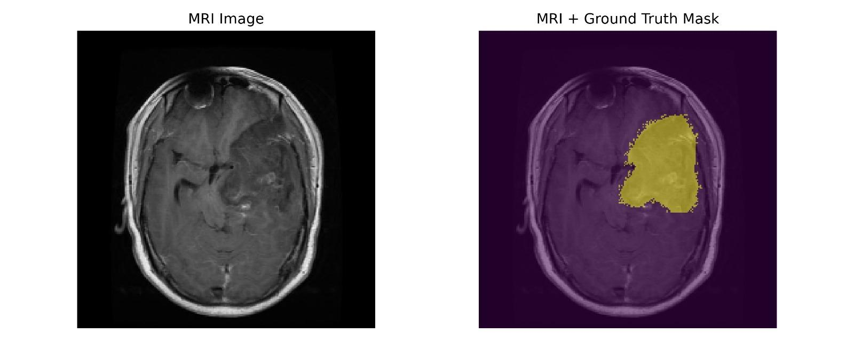

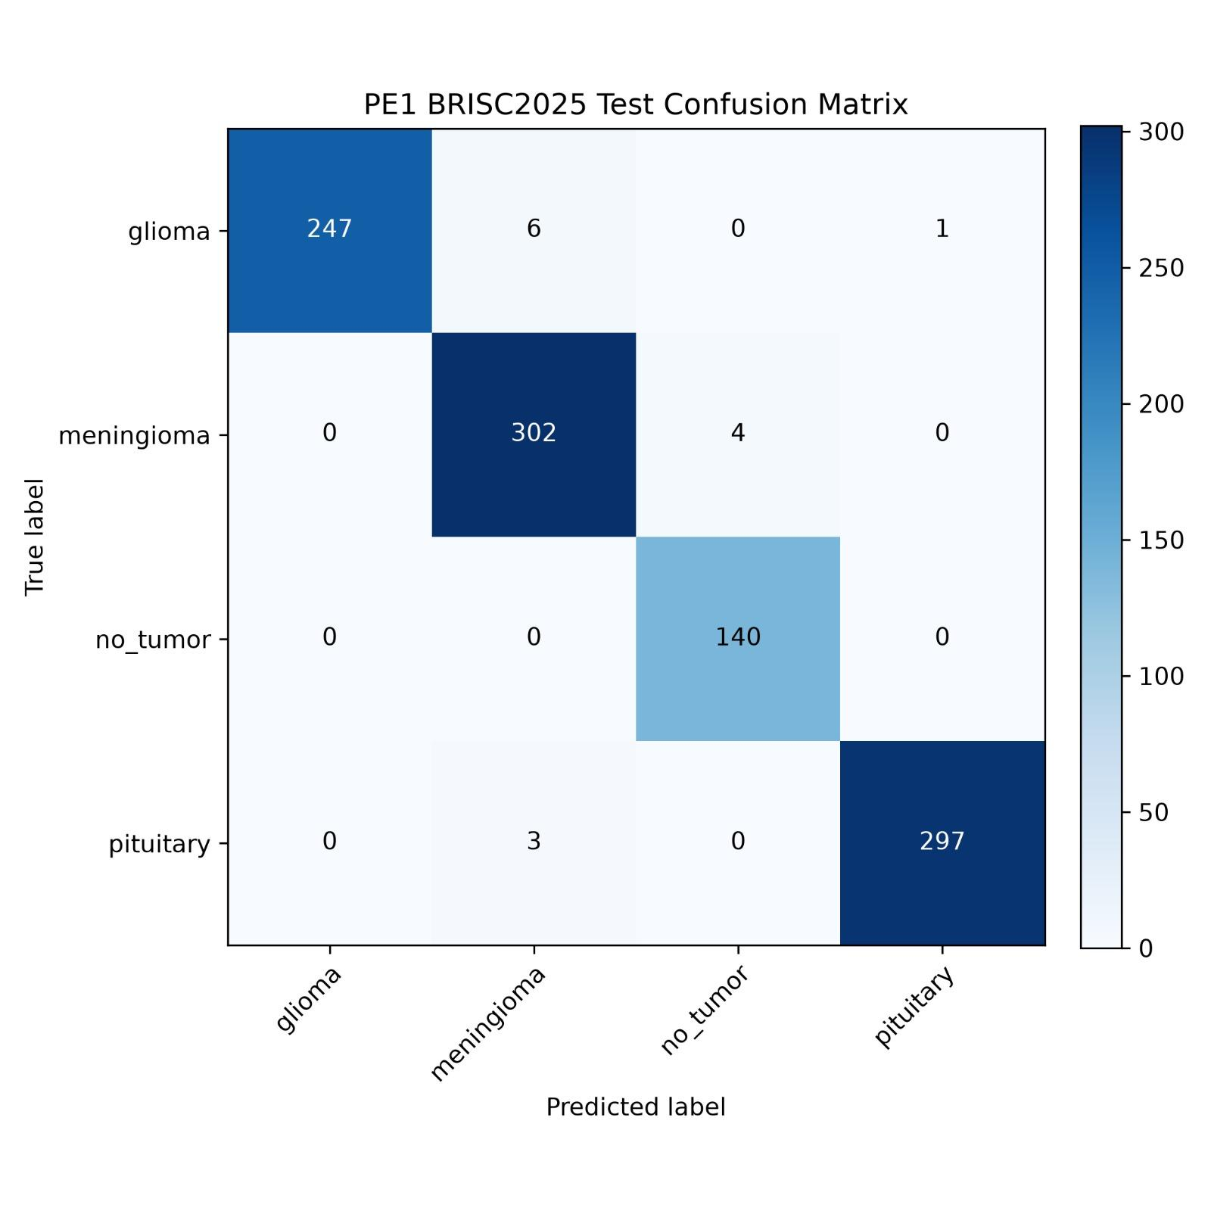

Summary of the Experimental Findings
The experiment does not support the claim that a larger EfficientNet backbone and a deeper classification head automatically improve results on this dataset. PE1 increases model capacity by approximately 76.25%, yet its test accuracy and macro F1-score are lower than those of the B1 baseline. Its recorded inference latency is slightly lower, and its logged training duration is shorter in this run, but these computational observations do not offset the reduction in classification metrics for the main objective of the experiment. The numerical findings reported here are intended to provide the basis for the subsequent discussion of possible reasons, limitations, and future improvements.

- DISCUSSION
The study examined a modified classification pipeline, which involved using EfficientNet-B3 together with an improved classification head (PE1) , and compared it with the EfficientNet-B1 baseline on the BRISC2025 dataset. Both approaches employed the same preprocessing, had the same 80/20 train validation split (with the seed of 42), used the same optimizer and loss function and were tested on the identical, unaltered 1000-image official test set. The baseline achieved an accuracy of 99.20% and a macro F1 score of 0.9931, while PE1 obtained an accuracy of 98.70% and a macro F1 score of 0.9871. It therefore follows that increasing the capacity of the backbone and adding a deeper head (including BatchNorm, dropout, and a 512-unit GELU layer ) did not lead to better classification performance on this dataset.
The price of that change was high. PE1 has 11.49 M parameters compared with 6.52 M for the baseline, which is an increase of about 76 per cent, and it resulted in 13 test errors as against roughly 8 for the baseline. Inference time was almost the same ( 1.63 ms versus 1.66 ms per image on Apple Silicon mps), so the bigger model brought about neither a significant slowdown nor any speed improvement. The measured time taken to train the model was about 50 per cent less for PE1 (approximately 72 minutes versus about 145 minutes), but this should not be interpreted as an advantage in terms of architecture. Since a larger network should take longer to train, the difference is most probably due to variations in the runtime environment between the two runs rather than to any difference in model efficiency.
An analysis carried out on a per-class basis reveals the areas in which PE1 fails to maintain accuracy. Glioma was the most accurate class (with an F1 score of 0.9921), then came pituitary (0.9916) and no tumor (0.9859). Meningioma was the weakest class (having an F1 score of 0.9787 and a recall of 0.9771), something that is in agreement with the finding in the baseline paper that meningioma is the class most frequently confused with its neighbours. Although the no-tumor class had perfect recall (1.0000) , it also had the lowest precision (0.9722) . This indicates that around four images of tumor were assigned to the no-tumor class, and this is the most serious type of clinical error because it could lead to a delay in diagnosis.The imbalance in the dataset may be responsible for this situation since the no-tumor category contains only 140 test images, so a small number of errors have a significant effect on its performance metrics.
There are several limitations. Since all the results are based on a single run using one fixed seed, a difference in accuracy of 0.5 points (amounting to 5 images out of 1000) cannot be regarded as statistically significant and it would be necessary to carry out repeated runs with the mean and standard deviation reported. The best checkpoint was obtained at epoch 13 out of 50, indicating that both models converge early and that the additional capacity of B3 is not being utilized on this size of dataset. The input resolution of 224 x 224 was also set to a level used by B1 rather than to B3’s native resolution, which might have limited B3. Lastly, the experiment only includes classification; segmentation and explainability (using Grad-CAM) have not been assessed, and since the dataset consists of a single curated source, generalization to other scanners and institutions has not been tested
- CONCLUSION
The experiment examined whether an EfficientNet-B3 model with an enhanced classification head would be able to beat the EfficientNet-B1 baseline in the task of classifying brain tumours into four categories-glioma , meningioma, no tumour, and pituitary using the BRISC2025 dataset. When the same training and evaluation procedures were followed, it wasn't the case. The baseline obtained an accuracy of 99.20% with 6.52 million parameters, whereas PE1 reached 98.70% accuracy with 11.49 million parameters, and the baseline remained superior in all the combined metrics.
The fact that these results show is that, with this dataset, model size is not the limiting factor. EfficientNet-B1 already provides a good compromise between accuracy and compactness and the additional parameters of B3 have not led to better predictions. Therefore, the compact baseline is still the more appropriate backbone for use in decision support.
Future research should involve carrying out multiple runs with significance testing , using B3 at its original input resolution, employing class -weighted losses or carrying out targeted augmentation for both meningioma and the no-tumour class, and also include evaluation on external data from multiple institutions. The classifier should also be integrated with the segmentation stage and Grad-CAM explainability should be incorporated in order to approach a full clinical workflow.

REFERENCES
[1] R. Alkharaan, J. Alobaidi, J. Bakarman, and H. Alshamlan, "Brain tumor classification and segmentation in MR images using EfficientNet and U-Net++ models," Diagnostics, vol. 16, no. 11, p. 1745, 2026, doi: 10.3390/diagnostics16111745.
[2] J. Deng, W. Dong, R. Socher, L.-J. Li, K. Li, and L. Fei-Fei, "ImageNet: A large-scale hierarchical image database," in Proc. IEEE Conf. Computer Vision and Pattern Recognition (CVPR), 2009, pp. 248–255.
[3] Z. N. K. Swati, Q. Zhao, M. Kabir, F. Ali, Z. Ali, S. Ahmed, and J. Lu, "Content-based brain tumor retrieval for MR images using transfer learning," IEEE Access, vol. 7, pp. 17809–17822, 2019.
[4] D. Filatov and G. N. A. H. Yar, "Brain tumor diagnosis and classification via pre-trained convolutional neural networks," arXiv:2208.00768, 2022.
[5] M. Gómez-Guzmán, L. Jiménez-Beristaín, E. García-Guerrero, O. López-Bonilla, U. Tamayo-Perez, J. Esqueda-Elizondo, K. Palomino-Vizcaino, and E. Inzunza-González, "Classifying brain tumors on magnetic resonance imaging by using convolutional neural networks," Electronics, vol. 12, no. 4, p. 955, 2023, doi: 10.3390/electronics12040955.
[6] A. Poudyal, N. Devkota, and G. Budha, "MRI-based brain tumor classification using transfer learning: A comparative analysis," Int. J. Comput. Appl., vol. 186, no. 40, 2024.
[7] H.-Y. Chen, Z.-Y. Wu, H.-F. Liu, C.-H. Liu, and S.-W. Feng, "Applying deep learning techniques in accurate brain tumor detection and classification," Eng. Proc., vol. 103, no. 1, p. 8, 2025.
[8] M. Tan and Q. V. Le, "EfficientNet: Rethinking model scaling for convolutional neural networks," in Proc. 36th Int. Conf. Machine Learning (ICML), PMLR 97, 2019, pp. 6105–6114.
[9] S. Ioffe and C. Szegedy, "Batch normalization: Accelerating deep network training by reducing internal covariate shift," in Proc. 32nd Int. Conf. Machine Learning (ICML), PMLR 37, 2015, pp. 448456.
[10] N. Srivastava, G. Hinton, A. Krizhevsky, I. Sutskever, and R. Salakhutdinov, "Dropout: A simple way to prevent neural networks from overfitting," J. Mach. Learn. Res., vol. 15, pp. 1929–1958, 2014.
[11] D. Hendrycks and K. Gimpel, "Gaussian error linear units (GELUs)," arXiv:1606.08415, 2016.
[12] Belugabilli, "BrainTumor-Reproduction," GitHub repository (EfficientNet-B1 baseline), 2026. [Online]. Available: https://github.com/Belugabilli/BrainTumor-Reproduction .
[13] A. Fateh, Y. Rezvani, S. Moayedi, S. Rezvani, F. Fateh, M. Fateh, and V. Abolghasemi, "BRISC: Annotated dataset for brain tumor segmentation and classification," Sci. Data, vol. 13, no. 1, 2026, doi: 10.1038/s41597-026-06753-y.
[14] R. Wightman, "PyTorch Image Models (timm)," GitHub repository, 2019. [Online]. Available: https://github.com/huggingface/pytorch-image-models
[15] D. P. Kingma and J. Ba, "Adam: A method for stochastic optimization," in Proc. 3rd Int. Conf. Learning Representations (ICLR), 2015, arXiv:1412.6980.
[16] Belugabilli, "BrainTumor-PE-1: EfficientNet-B3 brain tumor classification experiment (Project Exhibition 1)," GitHub repository, 2026. [Online]. Available: https://github.com/Belugabilli/BrainTumor-PE-1
[17] A. Paszke et al., "PyTorch: An imperative style, high-performance deep learning library," in Advances in Neural Information Processing Systems (NeurIPS), vol. 32, 2019.
[18] F. Pedregosa et al., "Scikit-learn: Machine learning in Python," J. Mach. Learn. Res., vol. 12, pp. 2825 -2830, 2011.
[19] R. R. Selvaraju, M. Cogswell, A. Das, R. Vedantam, D. Parikh, and D. Batra, "Grad-CAM: Visual explanations from deep networks via gradient-based localization," in Proc. IEEE Int. Conf. Computer Vision (ICCV), 2017, pp. 618-626.
[20] T. G. Dietterich, "Approximate statistical tests for comparing supervised classification learning algorithms," Neural Comput., vol. 10, no. 7, pp. 1895 -1923, 1998.

